|  |
| --- |
|  |
| 新概念 3 册 |
| Lesson52 Mud is mud |

Book

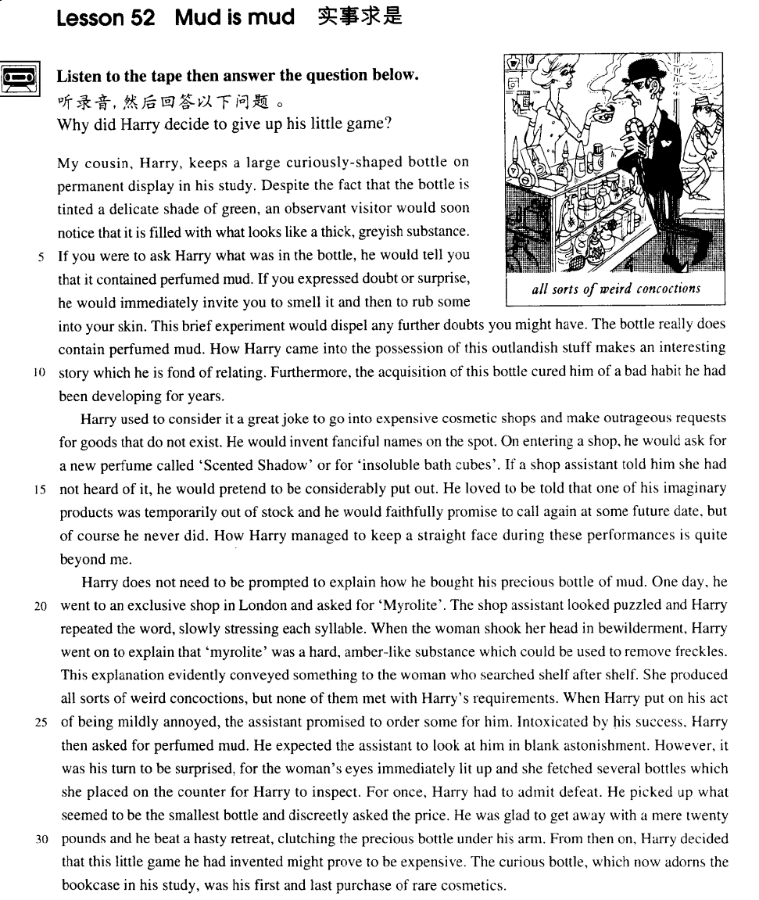

课文

My cousin, Harry, keeps a large curiously-shaped bottle on permanent display in his study.

我的堂兄哈里在他的书房里一直摆着一只形状古怪的大瓶子。

Despite the fact that the bottle is tinted a delicate shade of green, an observant visitor would soon notice that it is filled with what looks like a thick, greyish substance.

尽管那只瓶子呈淡绿色，但细心的客人很快就会发现瓶里装的是一种看上去黏稠，颜色发灰的东西。

If you were to ask Harry what was in the bottle, he would tell you that it contained perfumed mud.

要是你问哈里瓶里装着什么，他会告诉你是香水泥。

If you expressed doubt or surprise, he would immediately invite you to smell it and then to rub some into your skin.

如果你表示怀疑或惊奇，他会立即请你闻一闻，然后取出一些抹在你的皮肤上。

The brief experiment would dispel any further doubts she might have.

这一简单的试验会消除你可能存有的一切疑虑。

The bottle really does contain perfumed mud.

瓶里装的的确是香水泥。

How Harry came into the possession of this outlandish stuff makes an interesting story which he is fond of relating.

哈里如何得到这种稀奇古怪的东西的，这里有个有趣的故事，而且他挺爱把它讲给别人听。

Furthermore, the acquisition of this bottle cured him of a bad habit he had been developing for years.

此外，得到这瓶香水泥还治好了他多年的一个坏习惯。

Harry used to consider it a great joke to go into expensive cosmetic shops and make outrageous requests for goods that do not exist.

哈里曾认为走进一家名贵化妆品商店，荒唐地提出要买一种根本不存在的商品是件开心的事儿。

He would invent fanciful names on the spot.

他会当场编造出一些稀奇古怪的货名。

On entering a shop, he would ask for a new perfume called 'Scented Shadow' or for 'insoluble bath cubes'.

他走进商店后，会提出要一种名叫“香影”的新型香水或什么“不溶浴皂”。

If a shop assistant told him she had not heard of it, he would pretend to be considerably put out.

要是女售货员告诉他从未听说过这些东西，他会装出十分遗憾和不安的样子。

He loved to be told that one of his imaginary products was temporarily out of stock and he would faithfully promise to call again at some future date, but of course he never did.

他爱听售货员说他想像出来的那种东西暂时脱销，于是他就煞有介事地许诺改天再来光顾。当然，他再也不会来了。

How Harry managed to keep a straight face during these performances is quite beyond me.

我实在想像不出哈里在这些表演中是怎样装出一本正经的样子的。

Harry does not need to be prompted to explain how he bought his precious bottle of mud.

毋须暗示哈里就会向你讲起他买下那瓶珍贵香水泥的经过。

One day, he went to an exclusive shop in London and asked for 'Myrolite'.

一天，他去伦敦一家高级商店要买一种叫“密诺莱特”的东西，

The shop assistant looked puzzled and Harry repeated the word, slowly stressing each syllable.

店员露出诧异的神色。哈里又慢慢地，一字一顿说了一遍这个词，

When the woman shook her head in bewilderment, Harry went on to explain that 'myrolite' was a hard, amber-like substance which could be used to remove freckles.

那个女售货员还是迷惑不解地摇了摇头，哈里便进一步解释“密诺莱特”是一种质地坚硬、状似琥珀的东西，可以用来除去雀斑。

This explanation evidently conveyed something to the woman who searched shelf after shelf.

他的解释显然对女售货员有些启示。她一个货架接着一个货架地寻找，

She produced all sorts of weird concoctions, but none of them met with Harry's requirements.

拿出各种各样稀奇古怪的化妆品，但没有一样能够符合哈里的要求。

When Harry put on his act of being mildly annoyed, the assistant promised to order some for him.

哈里装出不高兴的样子时，女售货员答应为他定货。

Intoxicated by his success, Harry then asked for perfumed mud.

哈里为他的骗术而感到洋洋得意，又提出要买香水泥。

He expected the assistant to look at him in blank astonishment.

他原想女售货员会惊奇地望着他，不知所措，

However, it was his turn to be surprised, for the woman's eyes immediately lit up and she fetched several bottles which she placed on the counter for Harry to inspect.

没料到这回该轮到他自己吃惊了。因为那女售货员听完哈里的话后，马上眼睛一亮，拿出几瓶东西放在柜台上让哈里挑选。

For once, Harry had to admit defeat.

哈里只好认输。

He picked up what seemed to be the smallest bottle and discreetly asked the price.

他挑出一个看上去最小的瓶子，谨慎地问了价。

He was glad to get away with a mere ￡20 and he beat a hasty retreat, clutching the precious bottle under his arm.

他庆幸自己只破费了20英镑便得以脱身。他把那宝贵的瓶子放在腋下夹着，溜之大吉。

From then on, Harry decided that this little game he had invented might prove to be expensive.

从那以后，他认识到自己发明的小小恶作剧是要付出很大的代价的。

The curious bottle which now adorns the bookcase in his study was his first and last purchase of rare cosmetics.

在他书房的书柜里摆着那瓶形状古怪的香水泥就是他第一次也是最后一次购买的稀有化妆品。

词汇讲解

* **tint** [tɪnt] v. 染色，微染

**tint** v. **英文解释：**to slightly change the colour of something 染色，微染

* She's had her eyelashes tinted.
* Despite the fact that the bottle is **tinted** a delicate shade of green, …

**【近义词】【辨析】**

**dye** v. **英文解释：**colour sth., esp by dipping in a liquid 染色，浸染

* **dye** one's hair
* **dye** a white dress blue
* Its wool, which had been **dyed** black, had been washed clean by the rain!

**stain** v. **英文解释：**colour (wood, fabric, etc) with a substance that penetrates the material 染色，渍染，着色

* He **stained** the wood dark brown.
* We've decided to **stain** the shelves blue.

**colour** v. **英文解释：**put colour on (sth.), e.g. by painting, dyeing or staining 着色

* **colour** a picture colour a wall green
* **dispel** [dɪ'spel] v. 驱散，打消

**dispel** v. **英文解释：**to make sth. go away, esp. a belief, idea, or feeling 驱散，打消

**dispel** **doubts**（疑虑） / **fears**（恐惧） / **worries**（忧虑） / **rumors**（谣言） / **hesitations**（忧郁） / **prejudice**（偏见） … 驱散了… 、打消了…

* This brief experiment would **dispel** any further doubts you might have.
* Reading about them increases our understanding without **dispelling** our fears.

**【词根】**

“**pel**” = **push** 推

**dispel** 驱散，消除（尤指感觉或信仰）

**propel** 推进；驱使；激励；驱策

**repel**  驱逐；开除

**expel** 驱逐；开除

**compel** 强迫，迫使；强使发生

**impel** 推动；驱使；激励

**be / feel compelled to do**  （强调外界压力）

**be / feel impelled to do** （强调背心动力）

* **outlandish [aʊt'lændɪʃ]** adj. 稀奇古怪的，非常怪异的

**outlandish** = **bizarre** adj. **英文解释：**extremely strange and unusual 稀奇古怪的，非常怪异的

* an **outlandish** hairstyle
* dancers in rather **bizarre** costumes

**【近义词】**表达“奇怪的”：

**strange** adj. 奇怪的；陌生的；外行的

**unusual** adj. 不寻常的；与众不同的；不平常的

**odd** adj. 奇数的；古怪的；剩余的；临时的；零散的

**peculiar** adj. 特殊的；独特的；奇怪的；罕见的

* At the time, this did not strike me as **odd**.
* These **peculiar** forms not only seemed designed to shock people emotionally, but to give them electric shocks as well!

**weird** adj. 怪异的；不可思议的；超自然的

* A really **weird** thing happened last night.

**eccentric** （行为）adj. 古怪的，反常的

* His eccentric **behaviour** lost him his job.
* True **eccentrics** never deliberately set out to draw attention to themselves.
* **outrageous** [aʊt'reɪdʒəs] adj. 令人震惊的，极其不合理的； 非常奇怪的

**outrageous** adj. **含义1**. very shocking or unreasonable 令人震惊的，极其不合理的

* His treatment of his wife is **outrageous**.
* She blames me for causing her father's death. But that's **outrageous**!
* Gesticulating wildly, the man acted as if he found my offer **outrageous**, but he eventually reduced the price to £10.

**outrageous** adj. **含义2**. extremely unusual and slightly amusing or shocking 非常奇怪的

* **outrageous** clothes / behaviour
* She says the most **outrageous** things sometimes.
* Harry used to consider it a great joke to go into expensive cosmetic shops and make **outrageous** requests for goods that do not exist.
* **freckle** ['frekl] n. 雀斑

**freckle** n. **英文解释：**one of the small light-brown spots on the human skin 雀斑

* Ann's face and back are covered with **freckles**.

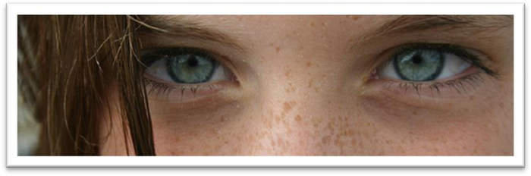

**mole** n. **英文解释：**small permanent dark spot on the human skin 痣

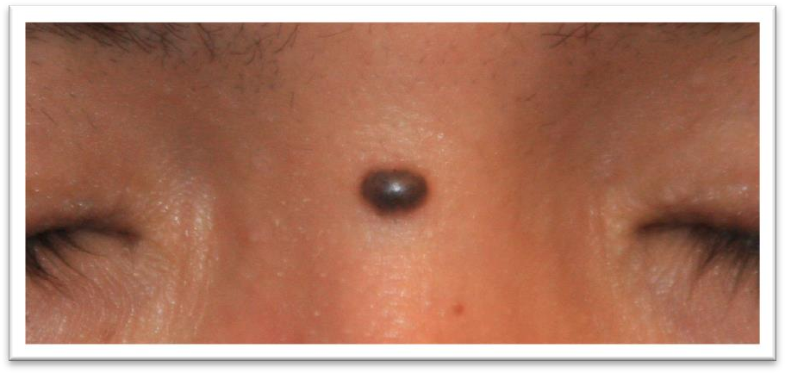

**beauty spot / beauty mark** n. **英文解释：**a small dark mark on a woman's face - used when you think it is attractive 美人痣

**acne** [U]n. 痤疮，粉刺

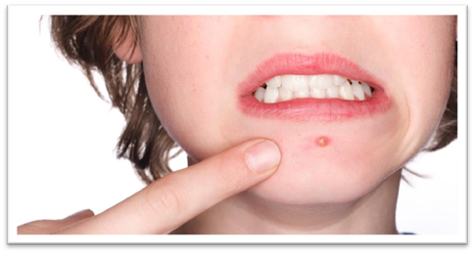

* Many adolescents suffer from **acne**.

**dimple** n. 酒窝

**chin dimple** n. 下巴窝



* **intoxicate** [ɪn'tɒksɪkeɪt] v. 使醉酒；使陶醉

**intoxicated** adj. **含义1**. (fml.) drunk 醉酒的

* The driver was clearly **intoxicated**.

**intoxicated** adj. **含义2**. feeling so excited or happy about something that you cannot think clearly 陶醉的

**be intoxicated by / with …** 对…陶醉的

* He was **intoxicated by / with** success.
* **Intoxicated by** his success, Harry then asked for perfumed mud.

**【扩展】**

**toxic** adj. 有毒的；中毒的

**noxious** adj. 有害的；有毒的；败坏道德的；讨厌的

**poisonous** adj. 有毒的；恶毒的；讨厌的

* **toxic** **chemicals**（化学物质） / **substances**（物质） / **gases**（气体） 有毒的…
* Carbon monoxide is a colorless, odorless and **noxious** gas.

课文讲解

# （标题）

# mud is mud

知识点（1）

**mud is mud [idiom]** 实话实说、坦白的说

**call a spade a spade** **[idiom]** 实话实说

**tell it like it is** **[idiom]** 实话实说

**tell somebody straight** 实话实说

* I **told her straight** that she was wrong.

**to be honest/frank**  实话实说、坦白的说

= **frankly**

* **To be honest/frank**, George isn’t very good at the job.
* **To be frankly**, George isn’t very good at the job.

# （第一段）

# My cousin, Harry, keeps a large curiously-shaped bottle on permanent display in his study.

知识点（1）

**keep** v. **英文解释：**have sth. in a particular place 在某处存放或放置某物

* Where do you **keep** the cutlery?
* Always **keep** your driving licence in a safe place.
* George **kept** a bottle of whiskey under his bed.

知识点（2）Lesson18

**shaped** adj.形状的；和其他词放在一起构成复合形容词

* **curiously**-**shaped**
* **oddly** **shaped** forms
* **curiously** **shaped** bits of metal She has a perfectly shaped figure.
* heart-shaped 心形的
* pear-shaped 梨形的
* V-shaped V形的

知识点（3）Lesson18

**on display** = **on show** 展示，陈列

* A collection of photographs was **on display** in the hall.
* Even people who take no interest in art cannot have failed to notice examples of modern sculpture **on display** in public places.
* My cousin, Harry, keeps a large curiously shaped bottle **on *permanent* display** in his study.
* Her work is **on *temporary* display** at the gallery.
* The locomotive is kept **on *static* display** in the National Railway Museum.

知识点（4）【课文仿写】

* **造句**：乔治在书房里一直陈列着一枚金牌。
* George keeps a gold medal on permanent display in his study.

# Despite the fact that the bottle is tinted a delicate shade of green, an observant visitor would soon notice that it is filled with what looks like a thick, greyish substance.

**语法分析:**

**Despite** the fact that the bottle is tinted a delicate shade of green（that... 同位语从句） （介词短语引导让步状语从句）, an observant visitor would soon notice ***that*** *it is filled with what looks like a thick greyish substance（****what****… 宾语从句）*. （**that**… 宾语从句）

知识点（1）

**despite the fact that ...** (fml.) **尽管**

= **in spite of the fact that ...** (fml.)

= **tough / although / even though / while ...**

**语法：**介词 + 名词 + 同位语从句 = 普通从属连词

**【复习】**Lesson4

**语法**：引导原因状语从句

**for the reason that …** (fml.)

**because of the fact that …**  (fml.)

**due to the fact that …** (fml.)

**on account of the fact that …** (fml.)

= **because …**

知识点（2）

**delicate / light** adj. 颜色淡的，浅色的

**dark / deep**  adj. 颜色浓的，深色的

**bright**  adj. 颜色亮的，鲜艳的

知识点（3）

**shade** n. **英文解释：**a particular type of red, green, blue etc. 色度

**shade of …** 某种颜色的色度

* a delicate **shade of** green
* a bright **shade of** pink
* a deep **shade of** blue

知识点（4）

**observant** adj. **英文解释：**perceptive; eagle-eyed 善于观察的，敏锐的

**【扩展】**

**powers of observation** 观察力

知识点（5）

**greyish** (BrE) / **grayish** (AmE) adj. **英文解释：**slightly grey 浅灰色的，灰了吧唧的

**【扩展】**

**yellowish** 黄了吧唧的

**reddish** 红了吧唧的

**bluish** 蓝了吧唧的

**greenish** 绿了吧唧的

**blackish** 黑了吧唧的

**whitish** … 白了吧唧的

# If you were to ask Harry what was in the bottle, he would tell you that it contained perfumed mud.

**语法分析:**

If（if… 条件状语从句） you *were to（虚拟语气）* ask Harry what was in the bottle（宾语从句）, he *would* tell you *that it contained perfumed mud（宾语从句）*.

知识点（1） 复习

**语法：3.**与未来趋势相反的虚拟

If + S.+ should do, S.+ would / should / could / might + do

If + S.+ did / were to do, S.+ would / should / could / might + do

* If you ***were to ask***Harry what was in the bottle, he ***would***tell you that it contained perfumed mud.
* If you ***expressed***doubt or surprise, he ***would***immediately invite you to smell it and then to rub some into your skin.
* ***Were***you *to ask* Harry what was in the bottle, he *would* tell you that it contained perfumed mud. （倒装）

**【复习】**Lesson4 2

**语法复习：虚拟语气if从句的虚拟**

1.与现在事实相反

If + S. + did / were, S. + would / should / could / might + do

2.与过去事实相反

If + S. + had done, S. + would / should / could / might + have done

3.与未来趋势相反

If + S.+ should do, S.+ would / should / could / might + do

If + S.+ did / were to do, S.+ would / should / could / might + do （强调及其不可能）

**语法：虚拟语气的倒装**（只用于书面语）**；if从句的虚拟语气中，出现were**、**had**、**should可用倒装**；

* 1.与现在事实相反：
* If I **were** you, I would go abroad at once.
* **Were** I you, I would go abroad at once. （倒装）
* 2.与过去事实相反：
* If you **had** come here a little earlier just now, you might have met her.
* **Had** you come here a little earlier just now, you might have met her. （倒装）
* 3.与未来趋势相反
* If it **should** rain tomorrow, you could stay at home.
* **Should** it rain tomorrow, you could stay at home. （倒装）
* 3.与未来趋势相反
* If the sun **were** to rise in the west, I would lend you the money.

**Were** the sun to rise in the west, I would lend you the money.

知识点（2）

**perfumed** adj. **英文解释：**pleasant to smell because perfume has been added or used 加香水的，有香味的

* **perfumed** soap / candles

# If you expressed doubt or surprise, he would immediately invite you to smell it and then to rub some into your skin.

**语法分析:**

（if… 条件状语从句）If you *expressed（虚拟语气）* doubt or surprise, he *would* immediately invite you *to smell it* and then *to rub some into your skin*.

知识点（1）

**rub sth. with sth.** 用…的涂抹、摩擦…

* She began **rubbing** her hair **with** a towel.
* A crowd of people gathered round him and a lady **rubbed** his arm **with** soap and butter, but George was firmly stuck.

**rub sth. into sth.** 用…的涂抹渗透进…

* **rub** salt **into** the wound
* **Rub** the cream well **into** your skin.

# The brief experiment would dispel any further doubts she might have.

知识点（1）

**dispel** **doubts**（疑虑） / **fears**（恐惧） / **worries**（忧虑） / **rumors**（谣言） / **hesitations**（忧郁） / **prejudice**（偏见） … 驱散了… 、打消了…

# The bottle really does contain perfumed mud.

# How Harry came into the possession of this outlandish stuff makes an interesting story which he is fond of relating.

**语法分析:**

How Harry came into the possession of this outlandish stuff （主语从句）makes an interesting story *which he is fond of relating（定语从句）*.

知识点（1）

**came into (the) possession of sth.**  (fml.)得到某个东西

= **get sth.**

* On her father's death, she **came into possession of** a vast fortune.
* How did the painting **come into your possession** (= how did you **get the painting**)?

知识点（2）

**stuff** n. [U] (infml.) things 东西，玩意儿

* I've got some sticky **stuff** on my shoe.
* Do you call this **stuff** beer?

知识点（3）

**be fond of …** **英文解释**: having a great liking for … 非常喜欢……

* I've always **been** very **fond of** you.
* John**'s** extremely **fond of** pointing out other people's mistakes.

知识点（4）

**relate sth. (to sb.)**（向某人）讲述某事

* We know instinctively, just as beekeepers with their bees, that misfortune might overtake us if the important events of our lives **were not related** to it.
* History does not **relate** whether his friend accepted his medical help, but in all probability he did.

# Furthermore, the acquisition of this bottle cured him of a bad habit he had been developing for years.

**语法分析:**

*Furthermore（状语，递进）*, the acquisition of this bottle cured him of a bad habit *he had been developing for years（定语从句）*.

知识点（1）复习

表达“**此外、而且、还**”：（做状语）

**furthermore**

**further**

**what is more / what’s more**

**moreover**

**besides**

**in addition**

**additionally**

知识点（2）

**acquisition**

**英文解释1**: [U] the act of getting sth, especially knowledge, a skill, etc. （知识、技能等的）获得，得到

**英文解释2**: [C] something that sb buys to add to what they already own, usually sth valuable （多指贵重的）购得物

* the **acquisition** [U] of language
* The money will be spent on **acquisitions** [C] for the university library.

知识点（3）

**cure sb.**  治愈某人

**cure a disease** 治愈疾病

**cure sb. of a disease** 治好了某人的某个病

**【扩展】**

**heal sb.** 治愈某人

**heal sb. of a disease** 治好了某人的某个病

~~heal a disease~~ X错误表达

**There is no cure for …** 无药可治

知识点（4）

**develop / catch / acquire / form / cultivate / foster a habit** 养成一个习惯

**change / alter a habit** 改变了一个习惯

**correct a habit** 纠正了一个习惯

**abandon / give up / drop / discard / kick a habit** 改掉、戒除坏习惯

# （第二段）

# Harry used to consider it a great joke to go into expensive cosmetic shops and make outrageous requests for goods that do not exist.

**语法分析:**

Harry used to consider it（形式宾语） a great joke（宾语补足语） ***to go*** *into expensive cosmetic shops and make outrageous requests for goods* ***that（定语从句）*** *do not exist*.（**to go**…真正宾语）

知识点（1）Lesson6

**expensive** adj.高档的

* The **expensive** shops in a famous arcade near Piccadilly were just opening.

知识点（2）

**cosmetics** n. [pl.] 化妆品 （瓶瓶罐罐的化妆品）

* Lipstick and hair conditioner are **cosmetics**.

**【扩展】**

**make-up / makeup** n. [U] 化妆品（擦到脸上的化妆品）

* girls in heavy **make-up**
* She doesn't wear **makeup**.

**【辨析】**

**cosmetics** n. 化妆品

**cosmic** adj. 宇宙的（等于cosmical）

**cosmos** n. 宇宙

**comic** adj. 喜剧的；滑稽的；有趣的

**comet** n. [天] 彗星

知识点（3）

**make a … request for …** 要求得到某事

* **make** repeated **requests for** help
* They have **made** an urgent **request for** international aid.

**issue / make a … appeal for …** （非常诚挚的）呼吁、恳求

* The police have **issued** a new **appeal for** information.
* The girl's family have **made** a public **appeal for** help to try and catch her killer.

# He would invent fanciful names on the spot.

知识点（1）Lesson36

**语法：**would 和 used to do 类似，都可以表示过去习惯性的动作，如：

* One day in a week he **would** spend a whole day in silence.

**但注意：**would 不能用在故事开头，往往在故事开头用 used to do，而后面换为 would do，如：

* We **used to** work in the same office and we **would** often have coffee together.
* **课文梳理：Lesson52**
* Harry **used to** consider it a great joke to go into expensive cosmetic shops and make outrageous requests for goods that do not exist. He **would** invent fanciful names on the spot. On entering a shop, he **would** ask for a new perfume called 'Scented Shadow' or for 'insoluble bath cubes'. If a shop assistant told him she had not heard of it, he **would** pretend to be considerably put out. He loved to be told that one of his imaginary products was temporarily out of stock and he **would** faithfully promise to call again at some future date, but of course he never did.
* **课文梳理：Lesson36**
* We are less credulous than we **used to be**. In the 19th century, a novelist **would** bring his story to a conclusion by presenting his readers with a series of coincidences ― most of them wildly improbable.

知识点（2）

**do sth. on the spot** 当场（立刻）做某事

= **do sth. immediately**

* He had to **make** a decision **on the spot**.

# On entering a shop, he would ask for a new perfume called 'Scented Shadow' or for 'insoluble bath cubes'.

**语法分析:**

On entering a shop（时间状语）, he would ask *for a new perfume called 'Scented Shadow'（后置定语）* or *for 'insoluble bath cubes'*.

知识点（1）

**on** prep. **英文解释**：as soon as 刚一…（做时间状语）

* What was your reaction **on** seeing him?
* The curtain went up **on** the final act of the play and revealed the aristocrat sitting alone behind bars in his dark cell.

**in** prep. **英文解释**：during the act or process of 在……过程中（做时间状语）

* He tripped **in** racing for the bus.
* **In** the last act, a gaoler would always come on to the stage with a letter which he would hand to the prisoner.
* **In** seeking independence, they do not sacrifice their human dignity.

知识点（1）

**insoluble** adj. **英文解释**：cannot be **dissolved**; not **soluble** 不能溶解的

# If a shop assistant told him she had not heard of it, he would pretend to be considerably put out.

**语法分析:**

（if… 条件状语从句）If a shop assistant told him she had not heard of it（宾语从句）, he would pretend to be considerably put out.

知识点（1）

**put out** adj. [Br.E.] **[never before noun]** annoyed 气愤的，不悦的（做表语）

* He seemed a bit **put out** at not having been invited.

# He loved to be told that one of his imaginary products was temporarily out of stock and he would faithfully promise to call again at some future date, but of course he never did.

**语法分析:**

He loved to be told that one of his imaginary products was temporarily out of stock（宾语从句） and（大连词） he would faithfully promise to call again at some future date, but（小连词） of course he never did.

知识点（1）

**imaginary** adj. 虚构的

**imaginative** adj. 富于想象力的

* **真题：**
* She is a very ___B___ student. She’s always talking about travelling to outer space.

(A) imaginary adj. 虚构的，假想的；想像的；虚数的

(B) imaginative adj. 富于想象的；有创造力的

(C) imaginable adj. 可能的；可想像的

(D) imagining n. 想像

知识点（2）

**temporarily** adv. 暂时，临时

**permanently** adv. 长期，永久

知识点（3）

**in / out of stock**（商店中）有/无现货的

* Have you any grey pullovers **in stock**?
* I'm sorry, that swimsuit is temporarily **out of stock** in your size.

知识点（4）

**faithfully** adv. 忠诚地，诚恳地

* He had served the family **faithfully** for 40 years.
* Ann **faithfully** promised never to tell my secret.

知识点（5）

**call** v. [Br.E.] **英文解释**：to stop at a house or other place for a short time to see sb. or do sth. 在某处短暂停留以拜访某人或做某事

* She **called** for a chat.

**call in at sth（地点）**. 到某个地方短暂停留

* Will you **call in at** the supermarket for some eggs and milk?
* After crossing the equator, the captain **called in at** a port to have a new rudder fitted, but by now the Thermopylae was over 500 miles ahead.

知识点（6）

**at a … date 英文解释**：a time in the past or future 在过去或未来的某时

* The exact details of the plan will be worked out **at a later date**.
* Johnson had agreed **at an earlier date** to take on the role of chairman.
* The election is scheduled to take place **at an unspecified date** in the autumn.

# How Harry managed to keep a straight face during these performances is quite beyond me.

**语法分析:**

How Harry managed to keep a straight face during these performances（主语从句） is quite beyond me.

知识点（1）

**keep a straight face** **英文解释**：stop oneself from smiling and laughing 板着脸，忍住不笑

* Brian looked ridiculous in leather trousers, and I was desperately trying to **keep a straight face**.

**【派生】**

**straight-faced** adj. 板着脸的

* We laughed, but Chris was **straight-faced** and seemed a little offended by the joke.

知识点（2） Lesson40、41

**be beyond** sb. **英文解释**：to be too difficult for someone to understand 无法理解

* Why people are prepared to tolerate a four-hour journey each day for the dubious privilege of living in the country **is beyond me**.

**be quite / completely beyond sb.** 某人完全不能理解

* It'**s quite beyond me** why anyone would want to marry him.
* The system was complicated and **completely beyond the learners**.

# （第三段）

# Harry does not need to be prompted to explain how he bought his precious bottle of mud.

知识点（1）

**prompt** v. **英文解释**：to encourage sb. to speak by asking them questions or suggesting words that they could say 提问或提示以鼓励某人说

* 'And then what happened?' he **prompted**.
* The speaker was hesitant and had to be **prompted** occasionally by the chairman.

# One day, he went to an exclusive shop in London and asked for 'Myrolite'.

知识点（1）

**exclusive** adj. **含义1**：very expensive, and therefore available only to wealthy people 高级的，高档的

* an **exclusive** store / restaurant / neighborhood

**exclusive** adj. **含义2：**独家的

* Newspapers and magazines offered the family huge sums for the **exclusive** rights to publish stories and photographs.

# The shop assistant looked puzzled and Harry repeated the word, slowly stressing each syllable.

**语法分析:**

The shop assistant looked puzzled and Harry repeated the word, slowly stressing each syllable（repeated的伴随状语）.

知识点（1）

**stress** v. **英文解释**：to pronounce a word or part of a word so that it sounds louder or more forceful 重读

* The word 'machine' is **stressed** on the second syllable.

# When the woman shook her head in bewilderment, Harry went on to explain that 'myrolite' was a hard, amber-like substance which could be used to remove freckles.

**语法分析:**

When the woman shook her head in bewilderment（固定搭配） （时间状语从句）, Harry went on to explain *that ‘Myrolite’ was a hard, amber-like substance which could be used to remove freckles（which...定语从句）.* （that… 宾语从句）

知识点（1）

**in bewilderment** 迷惑

= **in confusion**

= **in puzzlement**

= **in perplexity**

* She looked at him **in bewilderment**.
* Matt stared at her **in confusion.**
* She frowned **in puzzlement.**
* Jane looked about **in perplexity**.

# This explanation evidently conveyed something to the woman who searched shelf after shelf.

知识点（1）

**convey sth. to sb.** 向某人传达或表达……

* Please **convey** my good wishes **to** your parents.
* If you see James, do **convey** my apologies **to** him.
* The poem perfectly **conveys to** the reader the poet’s feelings.

知识点（2）复习

**语法**：定语从句充当并列句

* This explanation evidently conveyed something to the woman **and she** searched shelf after shelf.
* This explanation evidently conveyed something to the woman **who** searched shelf after shelf.

知识点（3）Lesson37

**sth. after sth.** （一个又一个）

* … shelf after shelf …
* But when the train dawdled at ***station*****after** ***station***, I began to wonder.
* *day* **after** *day*
* *week* **after** *week*
* *year* **after** *year*
* *time* **after** *time*
* He fired *shot* **after** *shot*. 一枪又一枪
* Shelley sent him *letter* **after** *letter* to explain the delay. 一封又一封
* They sent *regiment* **after** *regiment* to attack us.
* In *factory* **after** *factory* we were shown machines built by the workers themselves.

# She produced all sorts of weird concoctions, but none of them met with Harry's requirements.

知识点（1）

**produce** v. **英文解释**：if you produce an object, you bring it out or present it, so that people can see or consider it 出示，拿出

* **Produce** your ticket!
* They made no effort to hide their amusement whenever I **produced** a packet of sweets from my pocket.

知识点（2）

**all sorts / kinds / types of sth.** 各种各样的，各式各样的……

**sth. of all sorts / kinds / types** 各种各样的，各式各样的……

* **all sorts of** silly jokes
* **all sorts of** weird concoctions
* **all sorts of** indignities
* vehicles **of all kinds**

知识点（3）

**concoction** n. **英文解释：**sth. that has been made out of several things mixed together 调制品，混合物

* a **concoction** of honey, yogurt, oats, and apples

知识点（4）

**requirement** n. **英文解释：** (usually requirements) [pl.] something that you need or want 所需的（或所要的）东西

**comply with / fulfill / meet (with) / satisfy / suit *one’s requirements*** *满足了某人的需要*

* The new computer system will **meet (with) *all our requirements***.

# When Harry put on his act of being mildly annoyed, the assistant promised to order some for him.

知识点（1）

**put on an act** 装模作样

* He wasn’t really angry; he just **put on an act**.

**put on sth.** 假装

* **put on** a smile 假笑
* **put on** airs 假装摆架子
* **put on** an injured expression 装出受伤

# Intoxicated by his success, Harry then asked for perfumed mud.

**语法分析:**

Intoxicated by his success（非谓语动词做原因状语）, Harry then asked for perfumed mud.

# He expected the assistant to look at him in blank astonishment.

知识点（1）

**blank** adj. **英文解释：**showing no feeling, understanding or interest 茫然的

* Steve looked **blank** and said he had no idea what I was talking about.

**blank astonishment** （惊讶得）目瞪口呆

* a look of **blank astonishment**

# However, it was his turn to be surprised, for the woman's eyes immediately lit up and she fetched several bottles which she placed on the counter for Harry to inspect.

**语法分析:**

However（状语，转折）, it was his turn to be surprised, （for...原因状语)for the woman's eyes immediately lit up and（内部并列） she fetched several bottles *which she placed on the counter for Harry to inspect（定语从句，充当并列句）*.

知识点（1）

**it is one’s turn (to do sth.)** 轮到某人做某事

* **It's your turn**.
* **It's our turn** to drive the kids to school this week.

知识点（2）Lesson11

**light up 英文解释：**if someone’s face or eyes light up, they show pleasure, excitement etc.（因喜悦、兴奋等脸上或眼中）露出光彩

* His eyes **lit up** with laughter.
* Her face **lit up** with pleasure.
* Suddenly, I saw the Officer's face **light up.**

知识点（3）复习

**语法**：定语从句充当并列句

* … she fetched several bottles **and** she placed them on the counter for Harry to inspect.
* … she fetched several bottles **which** she placed on the counter for Harry to inspect.

# For once, Harry had to admit defeat.

知识点（1）

**(just) for once** **英文解释：**used to say that sth. unusual happens, especially when you wish it would happen more often 这一回，这一次

* Be honest **for once**.
* **Just for once,** let me make my own decision.
* **For once** Colin was speechless.

知识点（2）

**accept / admit / concede defeat** 认输

* She is very determined, and will never **admit defeat**.
* The prime minister **conceded defeat** and resigned.

# He picked up what seemed to be the smallest bottle and discreetly asked the price.

知识点（1）

**discreet** adj. **英文解释：**careful not to cause embarrassment or attract too much attention, especially by keeping something secret 言行小心谨慎的

* The family made **discreet** enquiries about his background.
* They are very good assistants, very **discreet** — they wouldn't go shouting to the press about anything they discovered while working for you.

# He was glad to get away with a mere ￡20 and he beat a hasty retreat, clutching the precious bottle under his arm.

**语法分析:**

He was glad to get away with a mere 20 pounds and he beat a hasty retreat, clutching the precious bottle under his arm（伴随状语）.

知识点（1）Lesson34、37

**a mere …** 仅仅……

1. **a mere** 后跟单数名词时 = **only a / an**
2. 在其他情况下 **a mere = only**

* ① **a mere** 后跟单数名词时
* It went direct from my local station and the journey lasted **a mere** (=**only an**) hour and 17 minutes.
* He's **a mere** (=**only a**) child.
* He's not **a mere** (=**only a**) boxer: he's world champion.
* ② 在其他情况下 **a mere = only**
* **A mere** (=**Only**) 2% of their budget has been spent on publicity.
* He has often described to me how he picked up a masterpiece for **a mere** (=**only**) £50.
* Glancing at his map, he informed us that the next village was **a mere** (=**only**) twenty miles away.

知识点（2）

**beat a (hasty) retreat 英文解释：**leave a place quickly in order to avoid an embarrassing or dangerous situation 赶紧走了

* The cat **beat a hasty retreat** when it saw the dog was coming.
* I saw my aunt coming and **beat a hasty retreat**.

知识点（3）

**clutch** v. **英文解释：**to hold something tightly because you do not want to lose it 紧紧抓住

* She was **clutching** a bottle of champagne.

# From then on, Harry decided that this little game he had invented might prove to be expensive.

**语法分析:**

From then on（时间状语）, Harry decided （that… 宾语从句）that this little game *he had invented（定语从句）* might prove to be expensive.

知识点（1）

**from then on** 从那以后

**from now on** 从今往后

知识点（2）Lesson43

**decide** 不一定译为“决定”，而常常译为“**（在考虑之后）确定，断定，认为**”，尤其是其后加 that 引导的宾语从句时。

* The pie committee **decided**（确定，断定，认为） that the best way to transport the dish would be by canal, so they insured it for the trip.
* From then on, Harry **decided**（确定，断定，认为） that this little game he had invented might prove to be expensive.
* I **decided**（确定，断定，认为） that I must have taken a wrong turning somewhere.
* Her first impulse was to go round all the rooms looking for the thieves, but then she **decided**（确定，断定，认为） that at her age it might be more prudent to have someone with her, so she went to fetch the porter from his basement.

# The curious bottle which now adorns the bookcase in his study was his first and last purchase of rare cosmetics.

**语法分析:**

The curious bottle which now adorns the bookcase in his study（定语从句） was his first and last purchase of rare cosmetics.

知识点（1）

**adorn** v. (fml.) **英文解释：**to decorate sth. 装饰

* The walls were **adorned** with paintings.